

Contact: Jessica Lynne Miller
Owner/Creator, J.Lynne Cosmetics
press@jlynnecosmetics.com
http://www.jlynne.com • (480) 840-1702

J.Lynne Cosmetics Adds Smoulder Collection
To Ultra Intensity Mineral Eyeliner Line

Beautifully frame eyes with sultry, rich tones infused with eco-friendly ingredients.
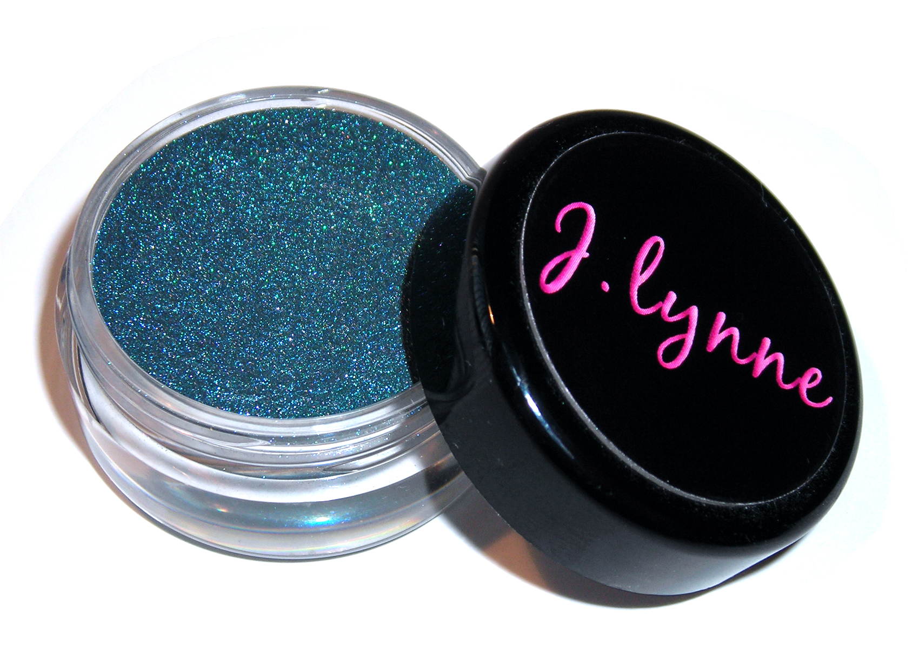

J.Lynne Cosmetics, cruelty free mineral makeup free of chemicals, synthetics and fillers, is proud to announce the creation of the Smoulder Collection as the latest addition to their current line of Ultra Intensity Mineral Eyeliners.

From rich aquatic teal to smouldering brown-black espresso tones, this line encompasses 10 vibrant shades ideal for all skin types and tones. Effortlessly apply wet or dry to create amazingly lined eyes with a mysterious, bold, and always dramatic finish.

Each mineral eyeliner is designed to frame eyes with sultry colors, enhancing the true intensity of your gaze. The Smoulder Collection’s deeply pigmented and vivid shades will define eyes with a beautifully rich luster, while providing an eco-friendly approach to superior makeup application.

Application Tips: J.Lynne Ultra Intensity Mineral Eyeliners may be applied dry for a soft, smoky effect or mixed with J.Lynne Eyeliner Sealant to create a long-wearing liquid formula. To wet-line, mix a small amount of mineral eyeliner powder with 1 - 2 drops of sealant. Using the tip of your brush, mix the powder and sealant together to create a liquid consistency. Apply with your favorite J.Lynne eyeliner brush by drawing a thin line directly next to your eyelashes.

Smoulder Collection Mineral Eyeliner Colors
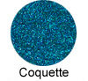 | Rich, aquatic teal with blue-green undertones
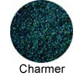 | Deepest emerald green
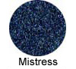 | Deep midnight blue with silver undertones
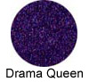 | Rich, luxe cool purple
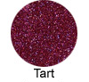 | Deep, sultry black-cherry scarlet
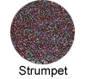 | Deep, smoky taupe suede with cool gray undertones
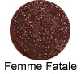 | Deep copper brown with burgundy undertones
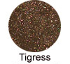 | Rich bronze with golden undertones
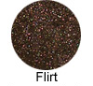 | Deep, smouldering brown-black espresso
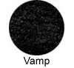 | Ultra deep jet black

